**Campaign Launcher for Existing E-commerce Platform**

**Problem Statement:**

You are given the responsibility to design the following product in an e-commerce company. Give an outline of the architecture, the schemas, and tools that you would use and mention why.

1. The company is thinking of creating a marketing team that launches discounts and offers campaigns. Each of these campaigns will have a campaign manager, who can choose the category of products or even select individual products, the start and end data of the campaign and the type of offers to include in the campaign.

2. Product categories could be generic like "Electronics", "Furniture" or more specific like "Gaming Laptops". In case of a product falling into more than one category in the same campaign, all the offers will be clubbed together. For example, if there is a cash back offer on Electronics and flat discount on Gaming Laptops, then for all gaming laptops, customers will enjoy both the cash back and the flat discount. There needs to be a layer in the system that combines all the offers for a product.

3. The type of offers could be anything from flat discounts, cash back, offers on credit cards, loyalty-based custom discounts, etc

4. You need to design the system that will allow campaign managers to create and launch a campaign. The e-commerce application will request your system to get the complete list of discounts/offers for the products in the cart at the time of checkout.

**Solution:**

**The 4 main subject areas in the architecture diagram are :**

1. **Cash backs on e-wallets and credit card related offers ,categorized in the data model as Payment Method based Offers**
2. **Customer purchase rewards, categorized as Loyalty Reward System**
3. **Discounts on products and product categories, categorized as Product Pricing and discount**
4. **All the discounts on products and product categories depends on Campaign and its managers**

**Payment Method based Offers:**

**Examples:**

1. **Cash back of 20% up to 100 Rs if Paytm is used for payment**
2. A discount of 10% can be availed with HDFC credit card on Amazon for electronic goods.

**Campaign managers or campaign cannot modify these discounts since, these totally depend on the institutes that offer the payment solution**

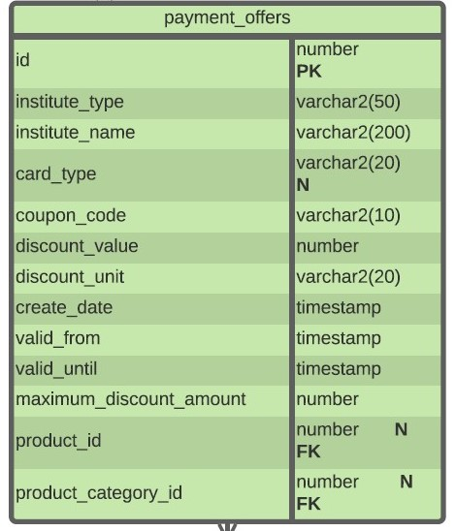

* id – The primary key of the table.
* institute_type – Whether the institute is a bank or a wallet service.
* institute_name – The name of the bank or wallet.
* card_type – Whether the offer is valid for credit cards, debit cards, or both.
* coupon_code – The related coupon code.
* discount_value – The value of the offer. Example : A discount of 10% can be availed with HDFC credit card on Amazon for electronic goods.
* discount_unit – Whether the discount is a percentage or flat currency amount. Above, it is a flat amount.
* create_date – The date that the record was added to the table.
* valid_from – When the offer starts. These offers can also be made for future dates.
* valid_until – When the offer ends.
* maximum_discount_amount – The maximum discount amount that can be offered with an order.
* product_id – The relevant product ID, when the offer is related to a specific product.
* product_category_id – The relevant product category ID, when the offer is related to a specific category.

If the offer is applicable for any order, irrespective of product or product category, both of these columns (product_id and product_category_id) would be NULL. Thus, I have kept both of these columns NULLABLE.

**Loyalty Reward System:**

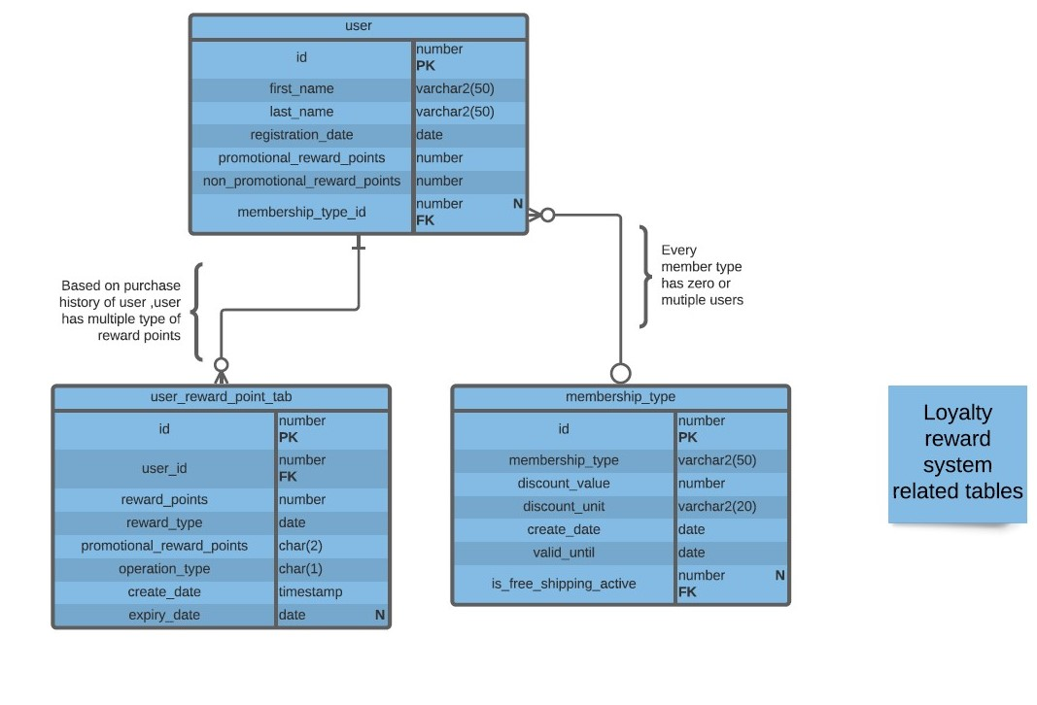

**The user table available here is already would be a part of existing E-commerce platform and can be pulled from there**

* promotional_reward_points**– The individual user’s current balance of promotional reward points. These reward points are usually associated with an offer and can expire. In addition, there are restrictions on how these points can be used. They may be redeemed as partial payment for an order, but not as full payment. At this point, the max_reward_points_encash column I added to the product_category table should make more sense.**
* non_promotional_reward_points**– The user’s current balance of non-promotional reward points (such as a refund on a returned product). Many online retailers credit non-promotional reward points to users’ reward accounts instead of refunding the purchase amount to the payment source. These points have no expiry date, and customers can use them in subsequent orders with no major restrictions.**
* membership_type_id**– The customer’s current membership type – for example, an Amazon Prime customer. Customers with premium memberships often pay a certain amount each year in return for perks like free shipping or special members-only prices.  
  Since subscribing to a premium membership is optional, this column is NULLABLE.**
* **The membership_type table stores details about the types of memberships available. A customer can subscribe to any one of them. The columns in this table are:**
* id**– A unique ID number assigned to each membership type.**
* membership_type**– The name of a membership type – Prime, Silver, Gold, Platinum, etc.**
* discount_value**– The membership discount amount associated with the relevant membership type.**
* discount_unit**– If the discount is a percentage or a flat currency amount.**
* date_created**– When the membership was introduced.**
* valid_until**– When the membership type is no longer valid. Usually, membership types are valid indefinitely.**
* is_free_shipping_active**– Whether free shipping is offered to customers of a particular membership type.**
* **There are portals that have a predefined set of memberships and that track customers’ order history. They can set membership type for individual customers based on how active the customers are. This is also a good way of rewarding customers’ loyalty.**
* **The user_reward_point_log table records the reward point activity of individual customers. The columns in this table are:**
* id**– The primary key of this table.**
* user_id**– The related user ID.**
* reward_points**– The number of points to be credited to or debited from the customer’s account.**
* reward_type**– Whether points are promotional or non-promotional.**
* operation_type**– Whether the operation is a credit or debit.**
* create_date**– The date when the transaction occurred.**
* expiry_date**– The date when promotional reward points expire. Usually these points are valid for some months or years**.

**Examples:**

1. **Amazon prime membership**
2. **Amazon gift cards**
3. **E-Vouchers**
4. **Reward points**

**Campaign managers or campaign cannot modify these discounts since, these totally depend on purchase history of customer and their reward points balance. But the campaign can give discounts in the form of rewards.**

**Product Pricing and Discount:**

**N**

**N**

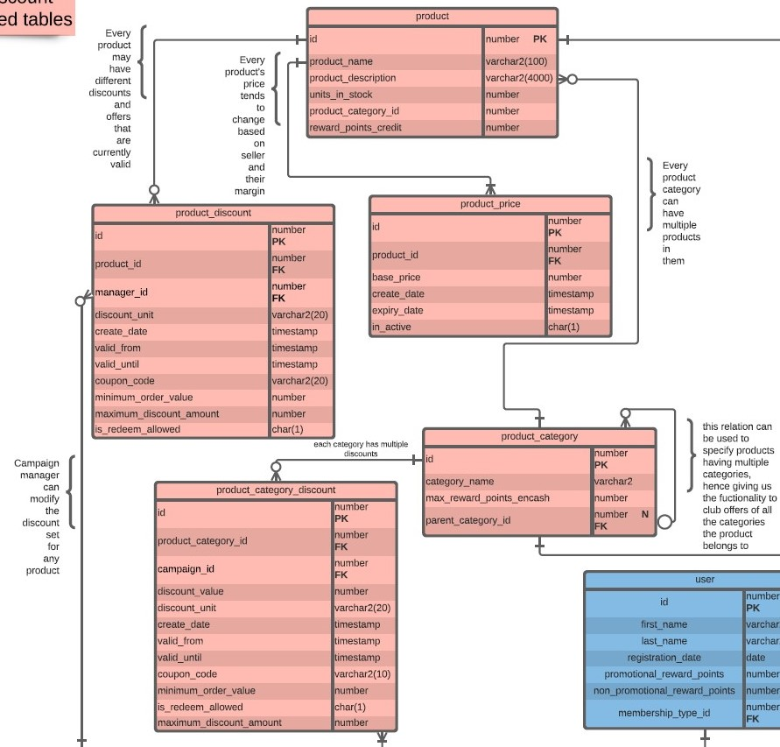

**The campaign and campaign managers are responsible for modifying the product category discount and product discount. The entire purpose of creating and launching the a campaign is to impose discounts on products and product based attributes.**

**The product table would already be a part of the existing E-commerce platform’s database and can be extracted easily. It would contain basic details like name ,description , when the product was listed ,the number of units of stock left, and other details**

**To this product table ,two new tables are added:**

* reward_points_credit – Each product comes with a set number of reward points that are credited to the customer’s account when they buy the product.
* product_category_id – This is the category to which the product belongs, such as electronics, clothing, food, or beverage.

The product_category table holds details about product categories and subcategories. You might be surprised to see the max_reward_points_encash column in this table. Usually, retailers impose some restrictions on the maximum reward points that can be redeemed with a single order. This depends primarily on the order’s product category. For example, a site selling vacation packages allows customers to pay up to 30% of their purchase with reward points when the customer is buying an international tour package, but only 10% of a domestic tour package can be redeemed. This is considering the fact that the profit margin is smaller with domestic tour packages than with international packages.

The product_pricing table stores pricing details for an individual product at any given time. The create_date, expiry_date and in_active columns are the most important, and they are also self-explanatory. I’ve added them to this table to capture pricing data, since price is a slowly changing dimension. There is one and only one active record for any product at any time.

E-commerce portals usually apply a discount to an entire set of products (a product category) rather than applying it to individual products. The product_category_discount table holds all discounts and offers currently valid for a product category. To understand the columns in this table, let’s look at the terms

30% OFF All Soaps

Coupon Code – SOAP30OFF

* Offer is valid until 30th April 2017.
* Customer will receive 30% off our entire range of soaps.
* Maximum discount is Rs 80.
* Coupon code can be used with reward points.
* Coupon code can be used only once and is not applicable with any other coupon code.
* Coupon code is applied to products’ MRP (maximum retail price).
* Taxes applicable on the discounted price.

Now, let’s take a look this table’s columns:

* id – The primary key of the table.
* product_category_id – The product category related to the discount. This is the “SOAP” subcategory in our example.
* discount_value – The amount of discount offered. In this case, the value is ”30”.
* discount_unit – The type of discount, i.e. a percentage (30%) or a flat currency amount ($30). We would expect values like “PERCENTAGE” or “CURRENCY”; in this example, it would be a percentage.
* create_date – The date when the offer was entered into the system.
* valid_from – When the offer starts. E-commerce portals may advertise an offer that only becomes available in the future.
* valid_until – The date when the offer is no longer valid. In the above example, this would be “30 April 2017”.
* Note: There are cases when an offer is valid for just a few minutes. Therefore, I’ve used the TIMESTAMP data type for the create_date, valid_from, and valid_until columns.
* coupon_code – A preset code that users enter during the checkout process to receive a discount. It is “SOAP30OFF” in this example.
* minimum_order_value – The minimum amount needed for an order to be eligible for a particular offer. In our example, since there is no minimum order value given, this column would be “0”.
* maximum_discount_amount – The maximum discount that a customer can get with this offer code.
* is_redeem_allowed – If customers can redeem reward points while using this coupon code.

The product_discount table is an exact replica of product_category_discount except that it holds the details of discounts and offers for individual products rather than entire product categories. Retail sites sometimes offer discounts on a particular product to boost its sales or to clear out their inventory

**Campaign Related Tables:**

* **Every campaign manager would be able to start a campaign and campaign manager would be able to set the discount for individual products directly**

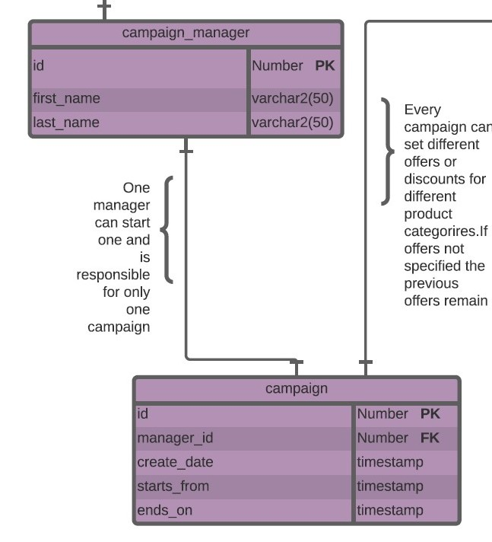

campaign_manager table :

* Id : **Uniquely indentifies each campaign manager**
* First_name : **First name of the manager**
* Last_name: **last name of the manager**

id **of** campaign_manager table  **is related to** manager_id **in the product_discount table. The** manager_id is nullable, if it remains null then there is no discount imposed by campaign manager , if manager_id is filled then a discount is imposed on the product by manager

campaign table :

* Id : **Uniquely indentifies each campaign started by a manager**
* Manager_ Id : **id of manger for the campaign**
* Create_date: **campaign created date-time**
* Starts_from: **campaign start date-time**
* ends_on: **campaign end date-time**

id **of** campaign table  **is related to** campaign_id **in the product_category_discount table. The** campaign _id is nullable, if it remains null then there is no discount imposed by campaign , if campaign _id is filled then a discount is imposed on the product_category by campaign.